Workshop Introduction to Database

WEEK 06

SQL Statements:
- Create a following table named Customers and insert their corresponding values using SQL statement:
CustomerID | CustomerName | City | Age | Country
1 | Maria Anders | Berlin | 22 | Germany
2 | Antonio Greizmann | Paris | 20 | France
3 | Antonio Moreno | México D.F. | 30 | Mexico
4 | Frank Lampard | London | 46 | UK
5 | Christina Berglund | Luleå | 15 | Spain
6 | Hanna Moos | Berlin | 49 | Germany
7 | Frédérique Citeaux | Strasbourg | 25 | France
8 | Zlatan Sommer | Madrid | 27 | Spain
9 | David Beckham | London | 37 | UK
10 | Christiano Ronaldo | Lisbon | 30 | Portugal

Ans:
Creating table for Customers

Inserting value for Customer
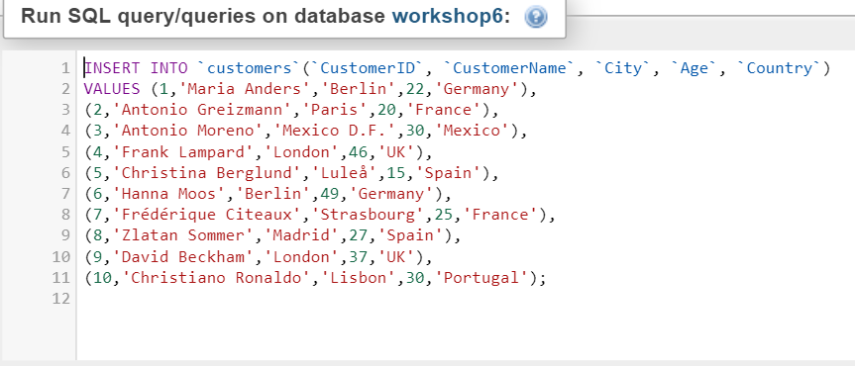

- Write a SQL statement to display all the customer details who lives in UK?
Ans:

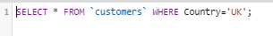

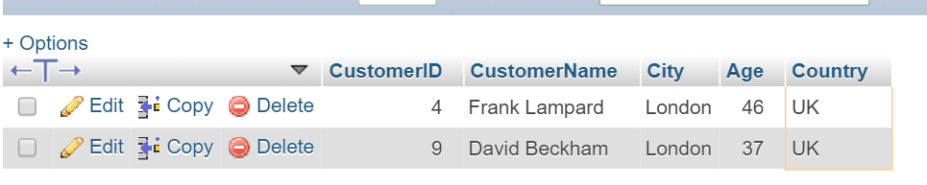

- Write a SQL statement to display the customer name and age who lives in country ‘UK’ and city ‘London’?
Ans:

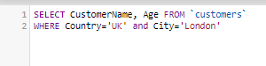

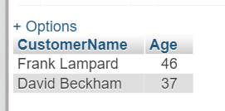
- Write a SQL statement to display the details of Customers whose age ranges from 20 to
50?
Ans:

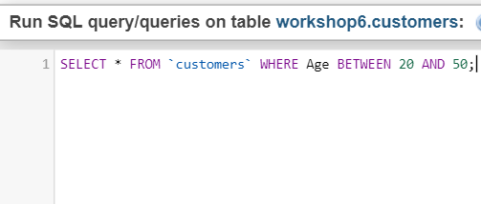

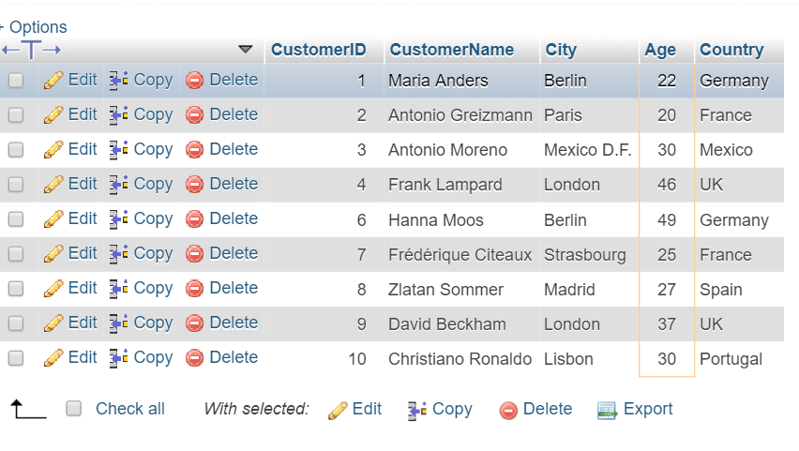

- Write a SQL statement to display the customer details who lives in Madrid, Berlin and London?
Ans:
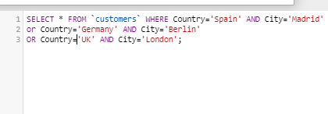

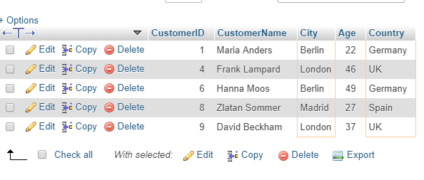
- Write a SQL statement to display the customer’s details who is not from Spain?
Ans:
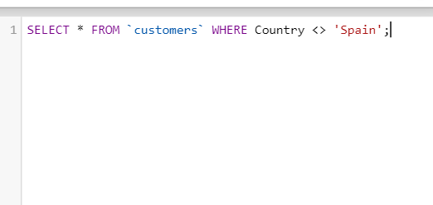

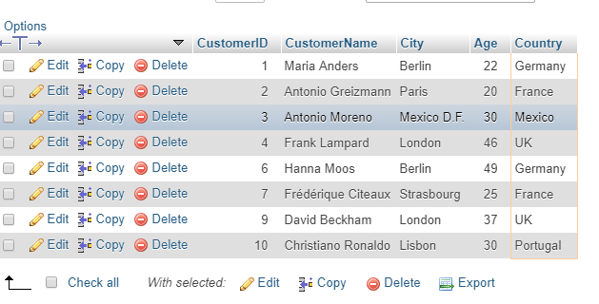
- Write a SQL statement to display the customer details where customer name starts with
‘C’?
Ans:
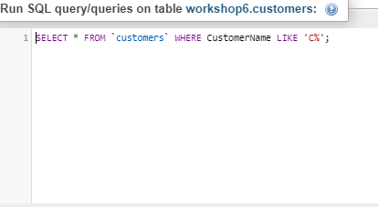

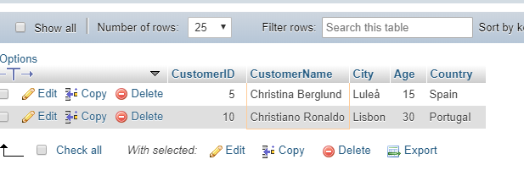

- Write a SQL statement to display the customer details who lives in UK and name ends with ‘D’?
Ans:

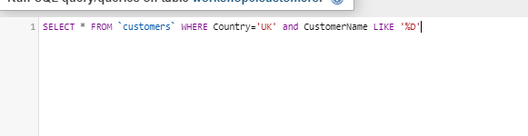

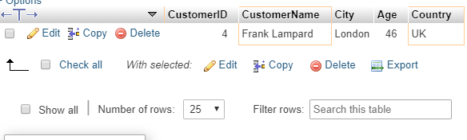

- Update the 9th row to Lionel Messi, Buenos Aires, 29, Argentina?
Ans:
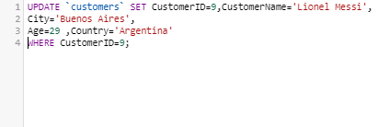

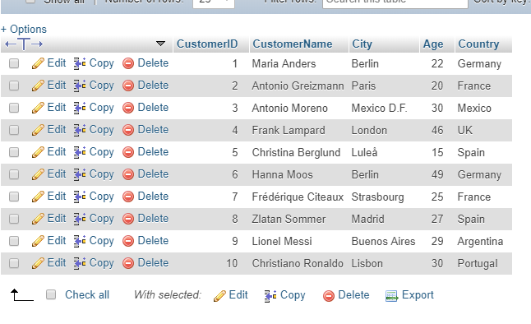

- Update all the customer name to ‘Luis Enrique’ where country is Spain?
Ans:
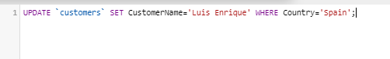

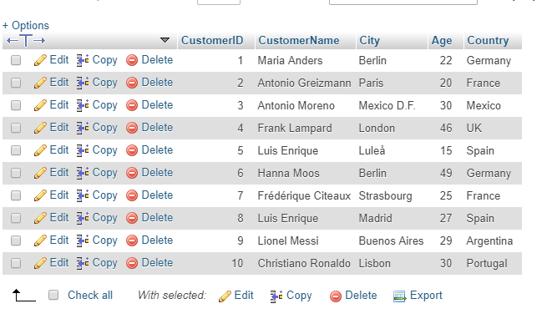

- Write a SQL statement to delete the customer record whose name is ‘Hana Moos’?
Ans:

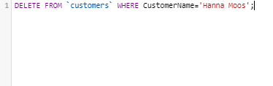

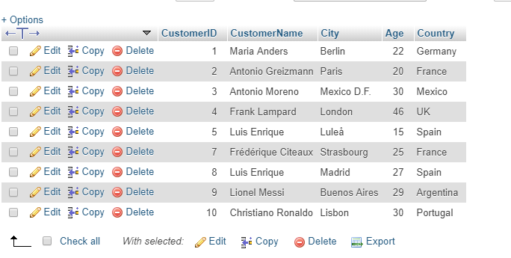
- Write a SQL statement to delete all the customer records who lives in Germany?
Ans:
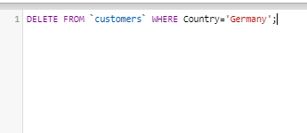
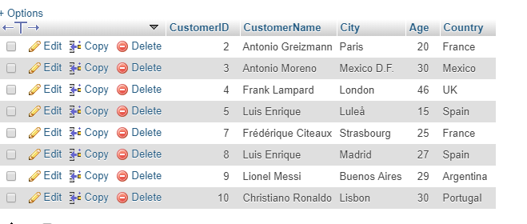
iAcademy

